Operating Systems Project Documentation
Multi-Threaded Chat Systems
Team Members
- Ebraam Ibrahim Sobhey – 2302597
- Ebraam Ehab Nieam – 2300316
- Beshoy George Thapet – 2301913
- Youstina Osama Yacoup – 2301897
- Demiana Malak Yacoub – 2302091

1. Introduction
This project was implemented as part of the Operating Systems course. The main purpose of the project is to understand how multitasking, multithreading, and inter-process communication work in real applications. Instead of only studying these concepts theoretically, this project applies them in a practical way by building two different chat systems.
The project consists of two chat systems. The first system allows users to communicate over a network using socket programming and multithreading. The second system allows users on the same machine to communicate using shared memory and synchronization mechanisms such as semaphores.

2. Project Objectives
- The main objectives of this project are:
- To understand how multithreading works in practice
- To implement client-server communication using sockets
- To use shared memory for communication between processes
- To apply synchronization using semaphores
- To design simple graphical user interfaces for both chat systems
- To ensure safe and correct message exchange between users

3. System Overview
The project consists of two independent systems:
- Chat System 1:
Uses sockets and multithreading. This system follows a client-server architecture and allows users on different machines to communicate over a network.
- Chat System 2:
Uses shared memory and semaphores. This system works on the same machine and allows multiple processes to exchange messages safely.
Each system demonstrates a different communication model used in operating systems.

Part I: Chat System 1 – Sockets and Multithreading

4. Chat System 1 Architecture
Chat System 1 follows the client-server model. A server application runs continuously and listens to incoming client connections on a specific port. When a client connects, the server creates a separate thread to handle communication with that client. This allows multiple clients to chat at the same time without blocking each other.

5. Server Implementation (Chat System 1)
5.1 Server Class Design
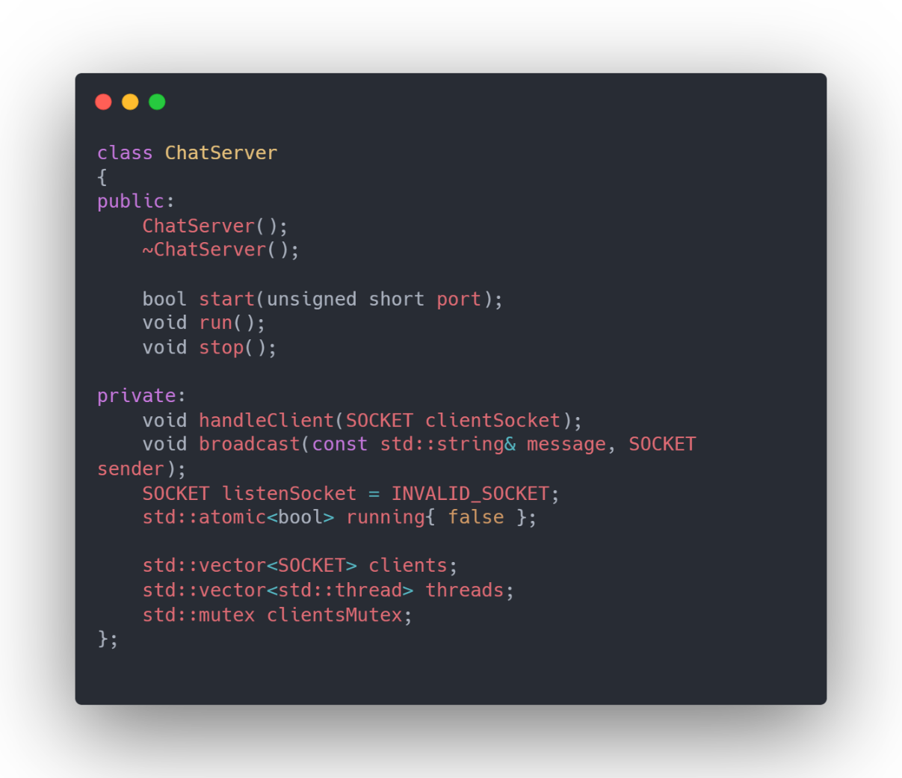
The server is implemented using a ChatServer class. This class is responsible for creating the listening socket, accepting clients, managing connected clients, and broadcasting messages. It also uses threads and mutexes to ensure safe concurrent execution.

5.2 Socket Initialization
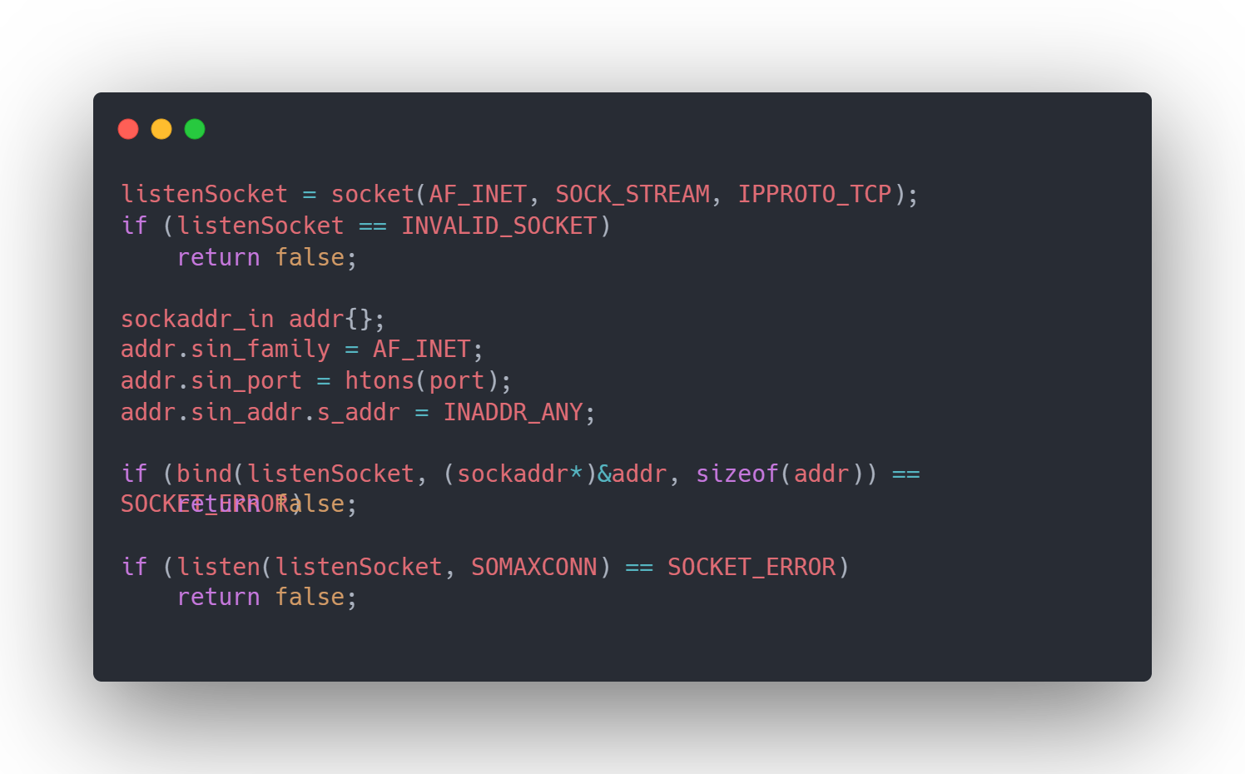
The server starts by initializing the Winsock library, creating a TCP socket, binding it to a port number, and listening for incoming connections. If any of these steps fail, the server stops execution
5.3 Accepting Clients and Multithreading
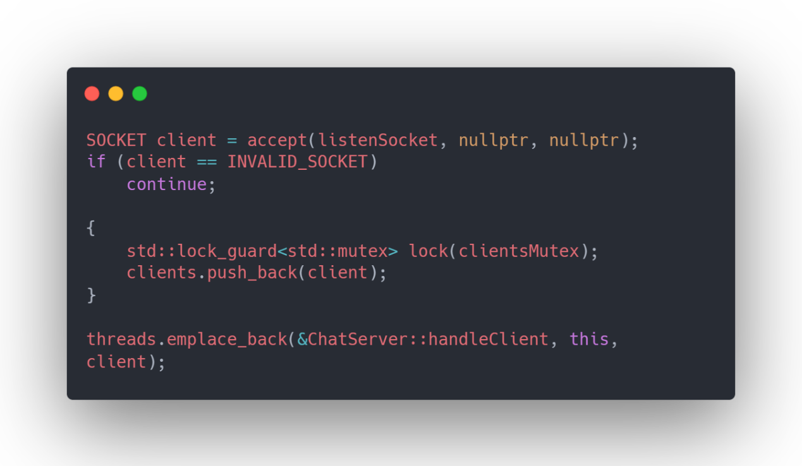
When a client connects to the server, the server accepts the connection and stores the client socket in a shared list. A new thread is then created to handle communication with that client. A mutex is used to protect the shared client list.

5.4 Client Handling and Broadcasting
Each client thread continuously listens to messages from its client. When a message is received, the server broadcasts it to all other connected clients. Synchronization is used to avoid race conditions when accessing shared resources.
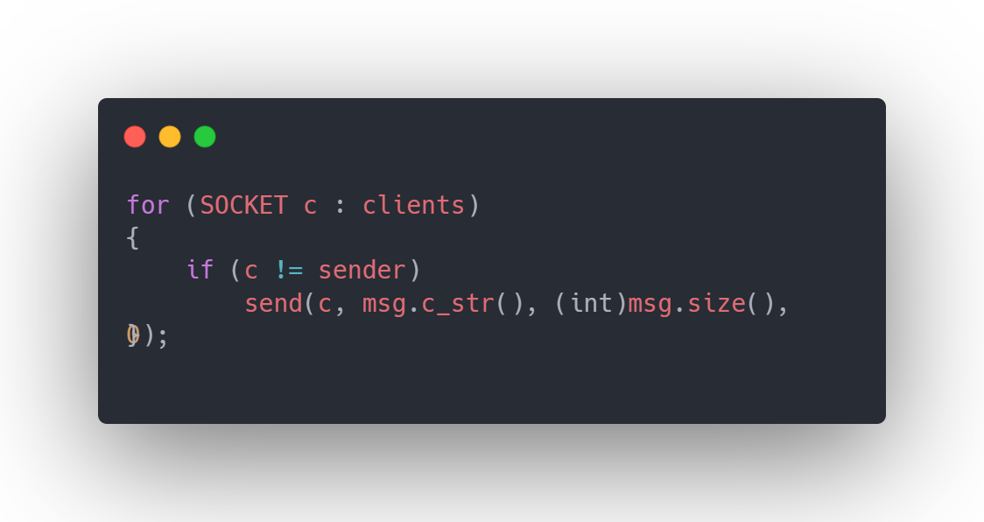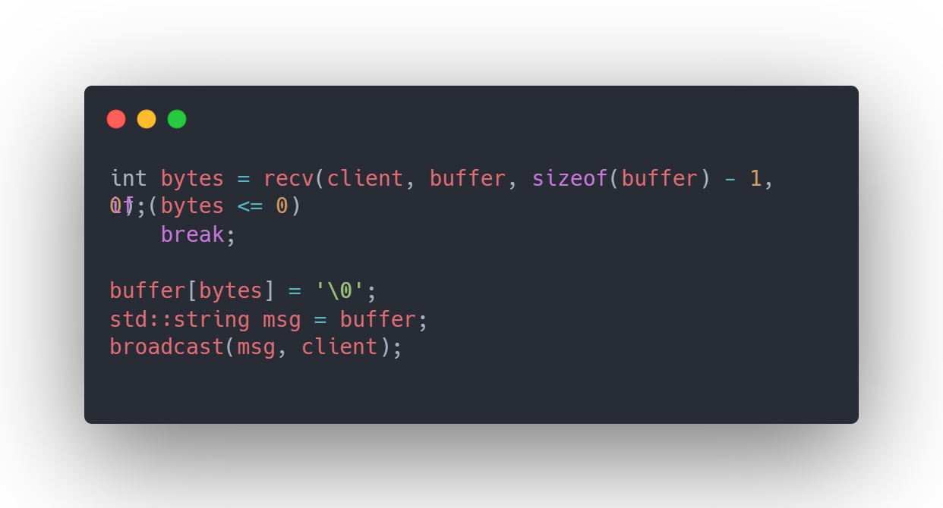
5.5 Server Main Function
The server main function creates a ChatServer object, starts the server on a specific port, and runs the main server loop.
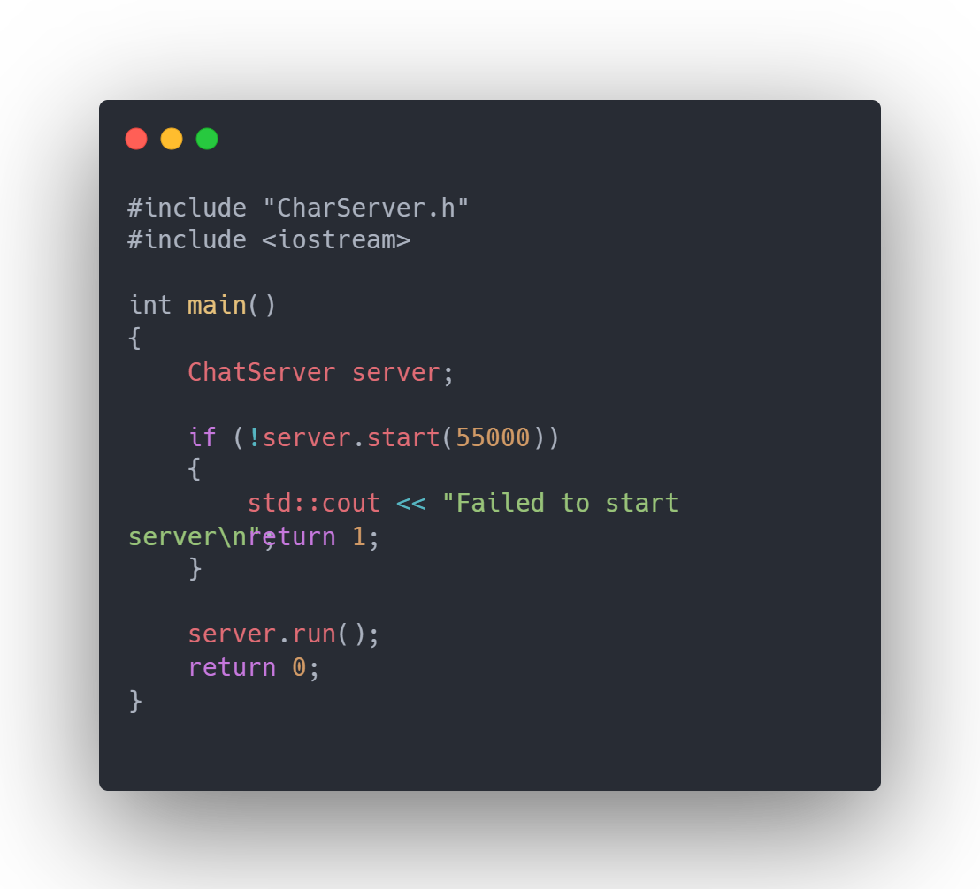

6. Client Implementation (Chat System 1)
6.1 Client Class Design
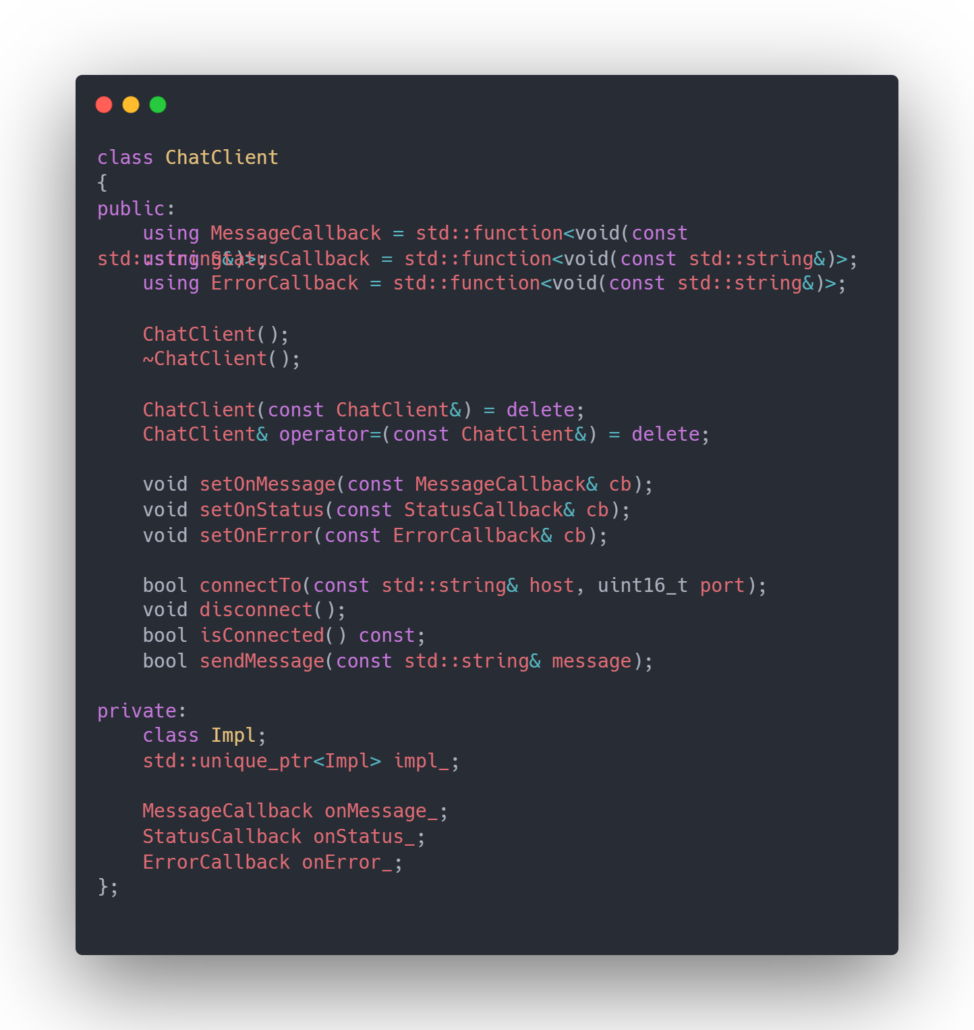
The client is implemented using a ChatClient class. This class handles connecting to the server, sending messages, receiving messages, and reporting connection status using callbacks.

6.2 Connecting to the Server
The client connects to the server using an IP address and port number. If the connection fails, an error message is displayed. Once connected, the client starts a separate thread to receive messages from the server.
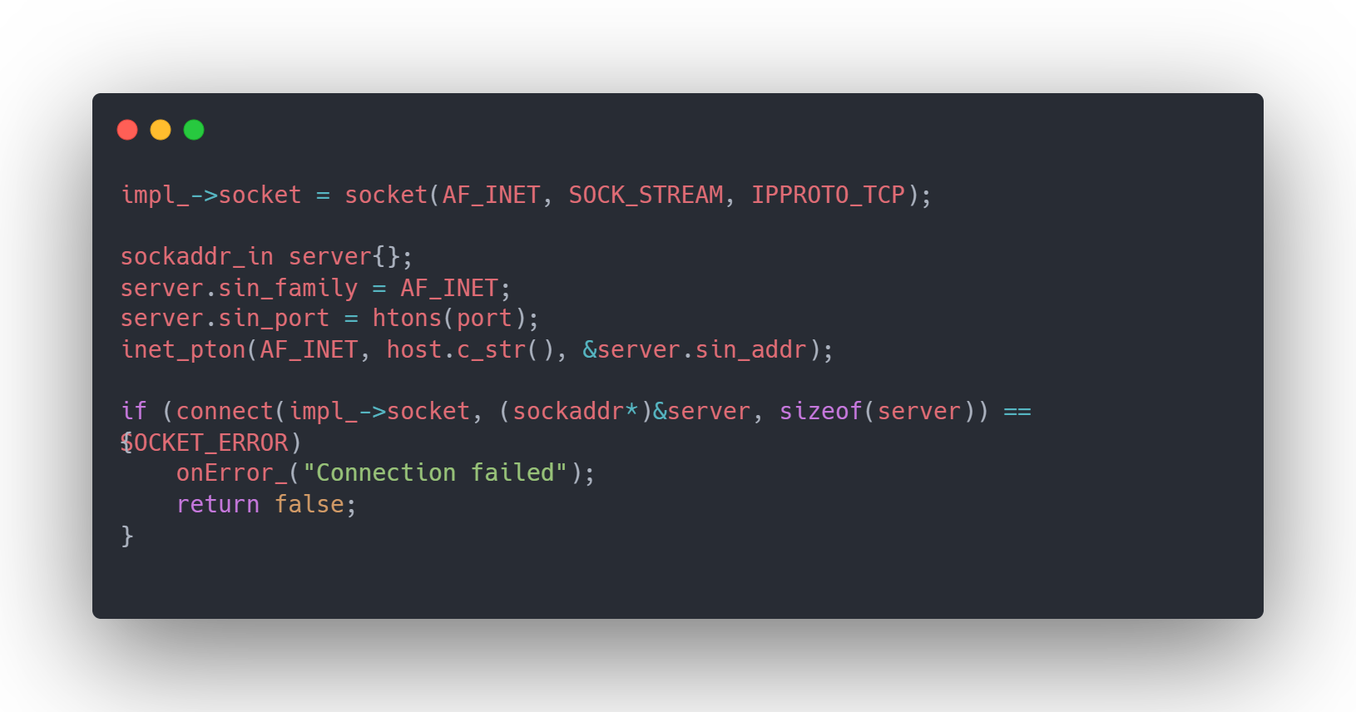
6.3 Sending and Receiving Messages
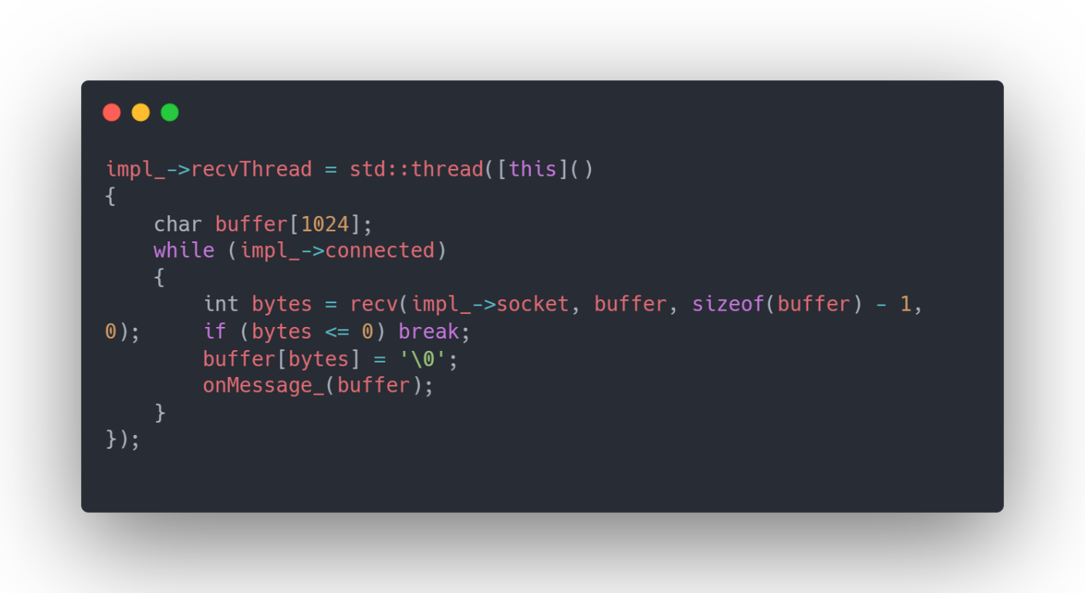
The client sends messages entered by the user to the server. Receiving messages is handled in a separate thread so that messages can arrive at any time without blocking user input.

7. Chat System 1 Graphical User Interface
The GUI for Chat System 1 provides input fields for server IP, port, and username. It also contains a chat display area and a send button. The GUI updates automatically when messages are received.
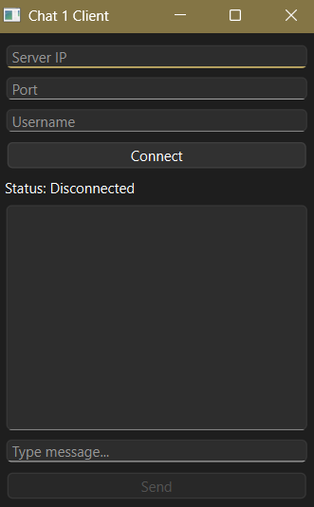

Chat System 1 GUI

Part II: Chat System 2 – Shared Memory and Synchronization
8. Chat System 2 Architecture
Chat System 2 allows communication between processes running on the same machine. A shared memory segment is created to store messages. Two processes (Process A and Process B) access this shared memory to exchange messages.

9. Shared Memory Implementation
A shared data structure is used to store messages and flags that indicate message availability. Each process attaches to the shared memory segment before accessing it.
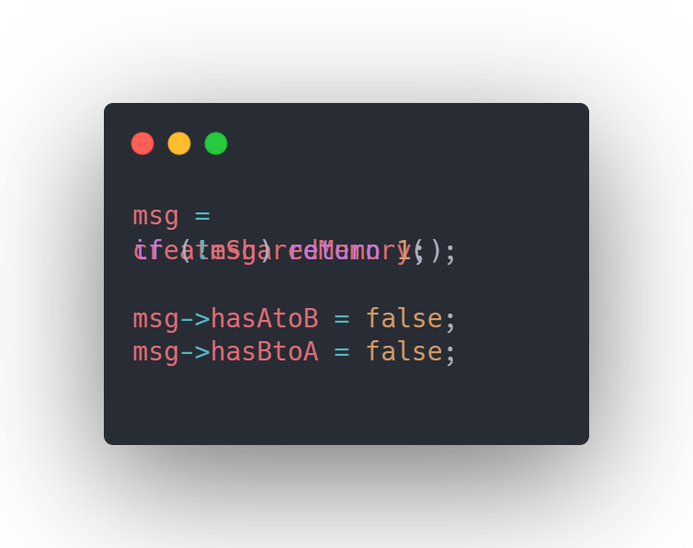

10. Synchronization Using Semaphores
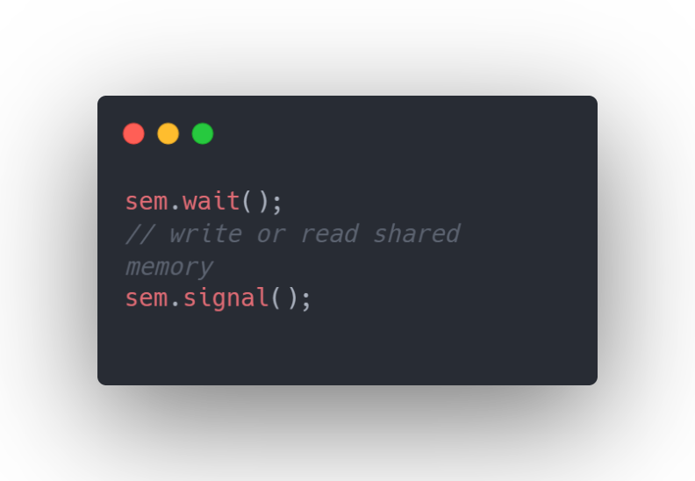
Semaphores are used to control access to shared memory. Before reading or writing, a process performs a semaphore wait operation. After finishing, it releases the semaphore. This prevents race conditions and ensures data consistency.

11. Chat System 2 Graphical User Interface
The GUI allows the user to choose between Process A and Process B, type messages, and view received messages. Communication happens through shared memory instead of network sockets.
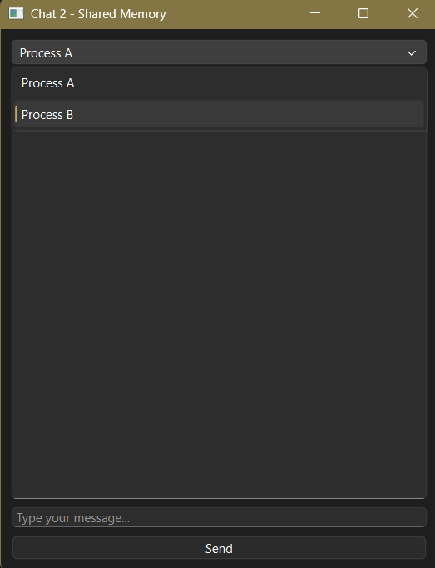

12. Testing and Results
Both chat systems were tested with multiple users. Chat System 1 successfully handled multiple clients connecting at the same time. Chat System 2 correctly synchronized access to shared memory and avoided race conditions. Messages were delivered reliably in both systems.

13. Division of Work
Each team member worked on a specific part of the project:
- Server architecture and sockets
- Multithreading and broadcasting
- Client implementation
- Shared memory design
- Semaphore synchronization and GUI integration
This ensured equal contribution from all team members.

14. Conclusion
This project provided practical experience with important operating system concepts such as multithreading, socket programming, shared memory, and synchronization. Implementing two different chat systems helped us understand the differences between network-based communication and inter-process communication on the same machine.

